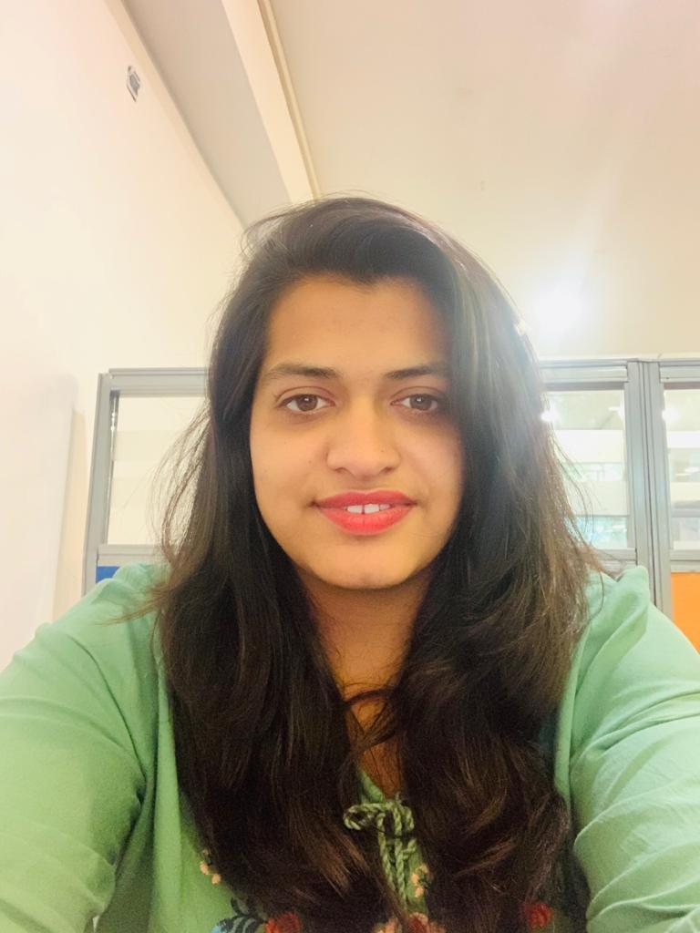
Human Resources Generalist with practical understanding of business needs. Highly effective at incorporating creative leadership skills to achieve business objectives. Equipped in driving innovative ideas to improve efficiency in meeting business deadlines and budget requirements.

Technical Skills
- Hiring and retention
- Training and Development
- Compensation/Payroll
- Employee relations
- Labor agreements
- Regulatory compliance
- Personnel records management
- EPF,ESIC
- Policies and practices

Education
12th – CBSE
Sophia Sr. Sec. School (Convent)
2011 65%

Bachelors of Business Administration
Lovely Professional University
2012-2015
Specialization- Human Resource Management 6 CGPA

Masters of Business Administration
Lovely Professional University
Specialization- Human Resource Management Perusing

Accomplishment
- Reduced employee turnover by 15% through implementation of new incentives program and bonus structure.
- Saved resources by reorganizing structure to eliminate unnecessary positions.
- Improved employee productivity and motivation by implementing short breaks for employee engagement activities.
Phone:
+91-8178466841

E-Mail:
garimasidana27993@gmail.com

Linkedin:
linkedin.com/in/garima—sidana-b38503aa

Twitter:
@garima59187245

Soft Skill
- Communication skills
- Strong EI
- Effective teamwork
- Problem solver
- Time management
- Decision making

Languages
English
Hindi
Punjabi

Hobbies
- Baking
- Bike Riding

GARIMA SIDANA

Experience
Royal Bank of Scotland
Associate Executive
Delhi NCR
Banking sector - Campus placement

Grofers India Pvt. Ltd.
Associate- Order Processing
Delhi NCR 06/2015-09/2015
Online grocery shopping

Falcon Force Pvt. Ltd.
- Wal-Mart Process
HR Executive
Delhi NCR 09/2015-02/2017
BPO

Digital Indya – Google partner
HR Generalist
Delhi NCR 02/2017-12/2017
Advertisement agency

Ludhiana Live Media Pvt. Ltd.
AM-Human Resource
Ludhiana, Punjab 03/2019-Present
Digital Marketing/Media

Garima Sidana
Date : _________
Location: _________

Highlights of Job Responsibilities
Grofers India Pvt. Ltd.
- Client servicing and collecting mandate requirements of customers.
- Meeting objectives and KPI targets for both Lead-time & output-quality.
- Interaction with Sales, COT (Channel of trade), & Service Delivery teams.

Falcon Force Pvt. Ltd.
- Planned and conducted new hire joining and orientation to foster positive attitude towards organizational objectives.
- Designing, re-framing and updating the on-boarding policy for PAN India new hires. Also Preparation and distribution of appointment letters.
- Planning and conducting employee survey and feedback for the entire induction program across all domestic locations through 30 – 60 – 90 days method.
- Managing and coordinating ISO and other account-specific audits from HR perspective
- Inform new hires of details such as duties and responsibilities, compensation, benefits, schedules, working conditions, or promotion opportunities.
Digital Indya – Google Partner
- Ensuring all payroll transactions are processed efficiently
- Collecting, calculating, and entering data in order to maintain and update payroll information
- Compiling summaries of earnings, taxes, deductions, leave, disability, and non-taxable wages
- Resolving payroll discrepancies
- Handling PF &ESIC (even visited govt. officials)

Ludhiana Live Media Pvt. Ltd.
- Took responsibility for Sourcing, Recruiting, Joining formalities to the exiting or leaving organization by an employee each and every documentation and procedures.
- Salary calculations (according to attendance +PF+ESIC including incentives & bonus)
- Tracking of employees working in field and maintaining personnel data and records.
- Most important took charge of regulatory compliances and permissions for certain activities.

